Travelling Light
27 May 2016 by Ian Gould

She picked her way around the large boulders that slowed her progress, as the Sun’s light reddened with the onset of dawn. This place was unfamiliar to her, but she had a sense of the direction she needed to hold to if she was to succeed. The day had started early for her, stiff from the previous day's journey she had once again shouldered her pack, taking stock of her position and set a course for the next stage.
Yesterday had been a little frustrating to say the least. It started well enough, but as is the way for travellers it had been fraught with complications. Well perhaps, “fraught” is a bit strong, but certainly things hadn’t gone as expected. As she ambled up the first hill of the day she allowed her memories of yesterday, the frustrations and thrills to ping pong around her creative mind. The day had its moments, she had to admit, but the goal of the day had not been met in totality.
Today would be different.
She said the phrase again in her mind with more conviction, “Today would be different.”
Then more slowly and deliberately, “Today would be different.”

It must be different if she was to accomplish the day's challenge. As she moved towards the top of the hill she had been climbing she caught sight of a ray of sunlight beaming downwards through the cloud bank that still clung doggedly to the horizon in the hope that it could withstand the Sun’s heat. Her steps slowed unconsciously as she changed her focus from her feet to the light. She looked at the ray and wondered if the people who were experiencing the light of that ray noticed that all around was cloudy and cold and yet they could bask in warmth. From her perspective it was so clear, but for those who lived in the moment of illumination, it might look so different. They may realise that all around was darker, but in all likelihood they would just think the Sun had come out and they would enjoy their moment unaware of their context.
“I suppose they wouldn’t even have looked around to realise that most of the sky was dark and they are living in a unique moment of light”, she pondered.
Unconsciously she had slowed her walk to a stop and was now staring into the distance. The ray had grown broader as the clouds gradually dissipated. The effect was less clear. Now the people certainly wouldn’t notice, she surmised. She remembered it was dawn and of course all those people were probably cuddled up in bed asleep and hadn’t noticed anything at all. Besides, how could they notice when they were directly under the light. You see the light. You are in the light. You experience the light. You don’t look around you to see where the light doesn’t shine. Gradually a green flame of irritation had flickered deep down in her. Why should they be in bed and she be out and about, up before dawn, up on the mountain top and not in the beautiful beam of light?
The flame of irritation grew stronger now in her as she saw how clear the differences were. They, in the ray of light, in bed with all the comforts, settled. She alone, in the wild, high up in the wind and the rain, the snow and the sleet, and to top it all, on the move with her meager belongings on her back. She could see it all so clearly from her vantage point. And they? Whoever “they” were, they probably couldn't see even if they tried and perhaps weren’t even looking. She felt a tear well up and gently trickle down her right cheek. She could feel the wind on it, cooling her face. Just a tear. But she recalled that each tear is precious and is remembered by those who care. But who could see this tear?
With no other human company on top of the hill she felt sad, not just because she had drawn a comparison between her life and others, but also because she wanted to share this journey with others. Not that she wanted them all to travel the same road, but she wanted them to experience this other life. This life of adventure, of being out and about, this time of travelling light, carrying less, moving along. Sure it was a life that each could choose or not, but it seemed sad to her that so many choose to try to make sure their lives were secure. Again, the ache of sadness came. Sadness that she seemed to be the only one up here seeing this beautiful sight. And yet, to be the only one seeing it made the view almost more precious. It felt like seeing more clearly than before, like studying a familiar place from a different observation point. The place itself doesn’t change, but it looks quite different from another angle.

She looked around to regain her own perspective and she noticed new things. She could understand her context in the light of distant objects. Although the wind is cool, it is a welcome companion to one who is walking. It is lovely to sit in the Sun and rest, but grey clouds are a wonderful respite when we are exerting ourselves and living an active life. Being aware of all the dark valleys and high hills that we will pass through does not make the journey as enjoyable. We only need enough light for the next step and we can always have enough light for the next step. In fact the way we need to travel, the truth about life and the light we seek all now live in us, so we can breathe and look and dream and listen to our hearts. We travel in the light.
Her feet had started walking again, down the gentle slope. The far off picture of the ray of Sun was gradually hidden from view by the distant towering trees. Saddened that such a beautiful picture had been marred by her comparison she hoped that those people were content, doing what they were doing, living their lives, using their time. Another little flame, of a different colour sputtered into life inside of her. She considered the flame and felt its feeble glow. What was this little life in her?
It came as a small surprise, almost a little shock, to find that the little flame of an orange colour that had seemingly just ignited itself in her might be called “hope”. Why have hope? Out here? With no human company… There is more to life than just what we see and what began in her was warming her gently. Something or someone seemed to be breathing on the flame. The light burned a little brighter despite her arguments. Hope was rising, she could feel it. Her spirit was moved, she could see it. She felt more free as she realised that she was not seen “as compared to others”, or “in the light of what other people do”; that is a trap. She was unique, made for a different road. Her eyes seemed clearer and she realised she had not just received enough light for the next step; she had also been given real hope.
Breathing in had a surprising effect on the hope-flame. The flame flickered and fluttered and then stood tall and confident deep inside of her. It was almost like this living flame wanted to pour out of her. The gentle in and out flowing of air was renewing her strength and resolve. Her mind sharpened and her heart beat more strongly. Her legs and arms tensed a little in readiness and she walked with determination.
Unconsciously she began to hum. Just a jaunty little ditty. As she walked she expressed her heart cry in time to her footsteps and breathing. It was a new song, just a happy little tune from inside. It was a freedom song. It began with just a few notes like raindrops, then it babbled like a brook, then over the waterfall the song went and splashed about in the pool below where it paused briefly before gathering itself together only to cascade down another waterfall in exuberant celebrating.
I am not really alone. I have never been alone. I am on a wonderful journey of discovery. I will walk through some dark valleys and crest some beautiful and lonely peaks and although I travel light, I am not alone. I will never be alone.
Confidence grew in her heart as she moved off the peak and down into the valley. She had seen which way to head for the day and she knew that if she stayed alert she would arrive at her destination. The mental picture of the overview from above would need to be referred to from time to time, especially where vision would be obscured by trees and shrubs. It would be easy to forget the destination when struggling to cross rivers, move across dangerous open plains or find a place to rest a weary head and body along the way. As she descended into the valley the Sun crept up. There was still enough light and now there was hope too.

Descending sobered her thinking. Why was she here at all? At first the thoughts dropped in like random objects raining from the sky into a junkyard. As she noticed each seemingly disconnected idea, they moved about the junkyard and joined together forming clear links. Then quite suddenly the disconnected parts all coalesced into a clear and focused picture. She remembered. He had called her name and that had changed everything.
He had asked her, “Dearly beloved. Will you, forsaking all else, take this adventure? Will you do this for me? For us?” The thoughts had run through her head like a pair of twin toddler boys. Craziness. Frenetic bouncing from joy to pain, from one thought to another. All the “what if’s” flooded in. The comparisons came to roost in her confused head. It made no sense. She was not the fittest or the biggest or the smartest. In fact she didn’t feel that she was the “est” of anything. But he just looked at her gently. It almost seemed like he knew her thoughts. The question hung in the air between them like a helium balloon that has just enough buoyancy to keep it from falling, but not quite enough to make it rise. It floated there seemingly undecided. It was as if a single light breath could coax it up or down, left or right. It seemed almost fragile. He seemed unconcerned about it. And she? She held her breathe so that she wouldn’t inadvertently move the balloon in any direction at all.
She needed to answer, but there was so much unconsidered. She knew life, as in “Life” was in the balance. She also knew that things could not continue as they were if she said, “yes”. Likewise they would be fundamentally different if she was to say, “no”. He seemed in no hurry for an answer. They sat in amiable silence.
Strange question, “Will you do this for me?” Did he mean, “Will you do this on my behalf?” Or was it, “Will you do this to gain me?” She pondered. What is the goal? Is the goal the destination or the journey? Or perhaps both? What about the “us”? “Will you do this for us?”, he had said. Was he speaking on behalf of others? Is it like the Royal “we”? Or was there something deeper?
The balloon-question still hung in the gently moving air between he and she. She looked at him and almost felt she heard him whisper, “Dear heart, it is in your heart to forsake all else, and take this mantle with us? Would you like to walk together?”
So much love filled the space between them and gently enveloped them that she almost felt she could breathe it in. The fragrance was freeing. It reminded her of how camphor cream gradually helps you to breathe more easily that you knew you could. She hardly dared to see if there was more to experience. She drew in a long, slow deep breath and held it. There were hints of …. so much … all swirls, distinct hues and shades of smell, separate and apart and also overlapping, like a rainbow, but in flavour. Yes, she could almost taste the fragrance now. It was delicately and delightfully delicious.
She felt she might burst with the breath. She so enjoyed the moment that she did not want to exhale. What if she never smelled it again? What if this was the last taste? But …….. what if that was just the beginning? She felt “Yes”. Gazing at that gentle face with those eyes and beginning to understand that heart, she felt a flutter in her insides. It was the start of a smile. Although she said nothing, she was answering the question he had asked. She smiled at him and knew that he knew that she wanted to know the thrill of walking together, sharing breath, being fully known and knowing fully. They would walk together forever.

Some references for words or phrases are below

You Are Here - a Song
Ian Gould, Tanya Gould, Simon Atherfold, Cheryl Atherfold

I need to travel light, travel light
I need to carry less, carry less
I want to move along, move along
To sing your freedom song

I’m living in your love, in your love
It overwhelms my heart, all my heart
Love flowing over me, under me
It comes to set me free

You are here, you are here, you catch each every tear
In the midst of my fear, I know you’re here
You are here, you are here, you catch each every tear
In the midst of my fear, I know you’re here

You carry me through the valleys, you walk me through my pain
You are my strength in the journey you are here, always here

Hope is rising - a song
Simon Atherfold, Tanya Gould & Ian Gould 2016

Hope is rising, hope is rising, can you feel it, can you feel it?
The Spirit is moving, Spirit is moving, can you see Him, can you see Him?
Choose to let your chains be broken, open up your heart and be free
Come on now breathe

Come to Jesus, come to Jesus, move a little closer, move a little closer
We are Whānau, we are Whānau, haere mai, haere mai
Choose to let your eyes be open, open up your heart and be free
Come on now breathe

Come to the table, there’s room for all
Let’s gather around, drink from the waterfall
There's a place here for you, there's a place here for me
And the best thing of all is all we have to do is breathe

Other References

“Then I heard the Lord asking, “Whom should I send as a messenger to this people? Who will go for us?” I said, “Here I am. Send me.””
Isaiah‬ 6:8‬ NLT‬‬
“You keep track of all my sorrows. You have collected all my tears in your bottle. You have recorded each one in your book.”
Psalms‬ 56:8‬ NLT‬‬
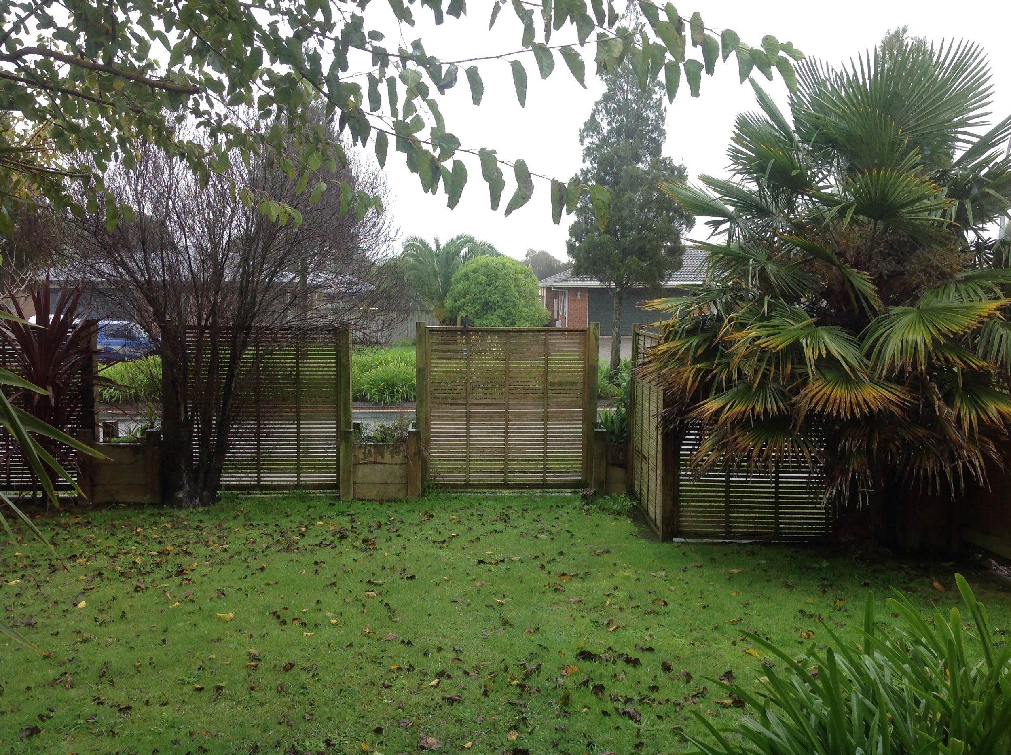

Our garden at the time of writing - lovely fine, gentle rain. And a beautiful tui on the fence.

